**Shell Scripting for DevOps**

Shell scripting is valuable for any DevOps engineer. It facilitates computerization of repetitive activities, control of arrangements and proficient deployment procedures. Due to scripting, the engineers are capable of automating some of the tasks which include, creating and managing directories, performing directories backups, tracking system performance, and deploying applications among others. Shell scripts aid in maintaining the integrity and quality of the process of deploying critical applications, mainly for CI/CD systems.

**Example:**

Suppose you have frequently to write a script that copies an application to various servers. Rather than copying files individually and setting up servers, one can create a shell script to do this. That is why this script will copy all the required files and even set the correct permissions on all the servers and even start the application.

**What is #!/bin/bash?**

#!/bin/bash is called a shebang. It tells the system which interpreter to use to execute the script. In this case, /bin/bash indicates that the script should be run using the Bash shell.

**Shell Script to Print a Message**

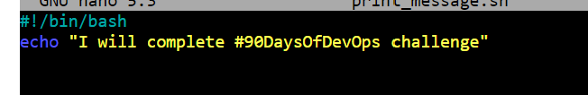

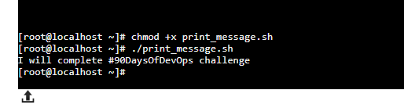

**Shell Script to Take User Input and Print Variables**

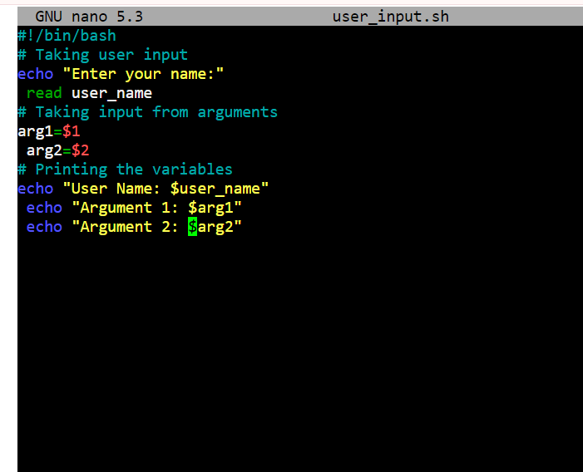

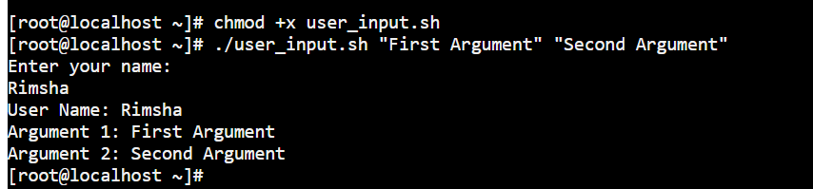

**Example of If-Else in Shell Scripting**

